**PROJECT TITLE: PRODUCT SALES ANALYSIS**

**DAC_Phase 5 Submission Document**

Team member: S.Sharmila[812121106030]

**INTRODUCTION:**

Product sales analysis is a crucial aspect of business operations that involves examining and evaluating the performance of a company's products in the market. This comprehensive assessment enables organizations to make informed decisions, optimize their product offerings, and ultimately boost profitability. By collecting and analyzing sales data, businesses gain valuable insights into consumer behavior, market trends, and the effectiveness of their sales strategies.

In today's dynamic and competitive business landscape, product sales analysis plays a pivotal role in understanding the strengths and weaknesses of a product portfolio. It allows companies to identify their top-performing products, as well as those that may be underperforming, which is essential for strategic planning and resource allocation.

This process involves various key elements, including sales trends, revenue projections, customer demographics, geographical distribution, inventory management, and marketing effectiveness. With the help of advanced data analytics and reporting tools, organizations can delve deep into these aspects and extract actionable intelligence to refine their sales strategies, optimize pricing, and enhance customer satisfaction.

In a world where data-driven decision-making is paramount, product sales analysis not only helps companies adapt to changing market conditions but also stay ahead of the competition. It empowers businesses to make informed choices, seize growth opportunities, and ultimately drive success in an ever-evolving marketplace.

**DAC** **Phase 1: Problem Definition and Design Thinking**

Project Definition: The project involves using IBM Cognos to analyze sales data and extract insightsabout top selling products, peak sales periods, and customer preferences. The objective is to helpbusinesses improve inventory management and marketing strategies by understanding sales trendsand customer behavior. This project includes defining analysis objectives, collecting sales data,designing relevant visualizations in IBM Cognos, and deriving actionable insights.

It is detailed study of market potential performance to detect strengths and weaknesses. The gathering,classifying, comparing &amp; studying of company‟s sales data, strictly speaking, gathering of sales data is not apart of analytical effort s but it substantially and vitally affects the quality of market potential.

Market potential provides additional information. For example that the increased sales volume camefrom product carrying a lower than average gross margin. Through sales analysis, management seeks insight on strong and weak territories, high volume, low volume products and type of customers providing satisfactoryand unsatisfactory sales volume. It uncovers details that otherwise lie hidden in the sales record.

It providesinformation that management needs to allocate sales efforts effectively. If sales management relies on the rawdata, the result may be misleading. It depends solely on summary of the sales data. It has no way to evaluate the effectiveness of its own activities and those of the sales force if we say that sales have gone up by 5% overprevious year‟s with 1% decline profit.

. It provide necessary information, management need in order to allocate future sales effort effectively.The role of sales manager in market potential is to make a detailed analysis of the available data ad use themproperly to initiate action.

The sample selection process requires the form of sample be specified. For this purpose, researcher hassubjectively decided which particular group will be part of the study. In a sample survey a small part of theentire population is subjected to the research. This sample is considered to be the true representative of theentire universe and decided upon certain criteria.

Data for market potential : Market potential is nothing but to collect, classify, study the company salesdata. Collection of data is not part of analytical part, but it vitally affect the quality of the sales analysis.

Market potential is generally based on data already in existence. It is called secondary data. Secondary data may be gathered either from internal sources such as invoice or shipping records or from external sources suchas marketing research agencies, government agencies, trade association and trade journals. Secondary data are often readily available but their use should be with caution.

The sales management has to rearrange them according to their needs. Himalaya Drug Company maintain their internal sales records in some detailed manner showing individuals sales, sales by products, by classes of customers, by size of order and other pertinent break downs of sales data.

Data are sometimesespecially collected for the purpose of finding the market potential. This may be called primary data and maybe collected under the control of sales management according to its needs. The main purpose of marketpotential is to convert raw sales data into actionable information for sales manager.

The process involving editing, tabulating and cross tabulating and also breaking them down into various way to make them comparable. When the sales planning is done, the sales manager finds out the potential market. Sales manager collects the information and analyses it and then compare the actual one with standards.

An evaluation program review both the nature and extend of sales force efforts and influence of external variables, once the degree of influence of controllable and uncontrollable factors are determined. Sales management can decide whether to corrective action or to revise the sales plan or both.

**DAC Phase 2: Innovation**

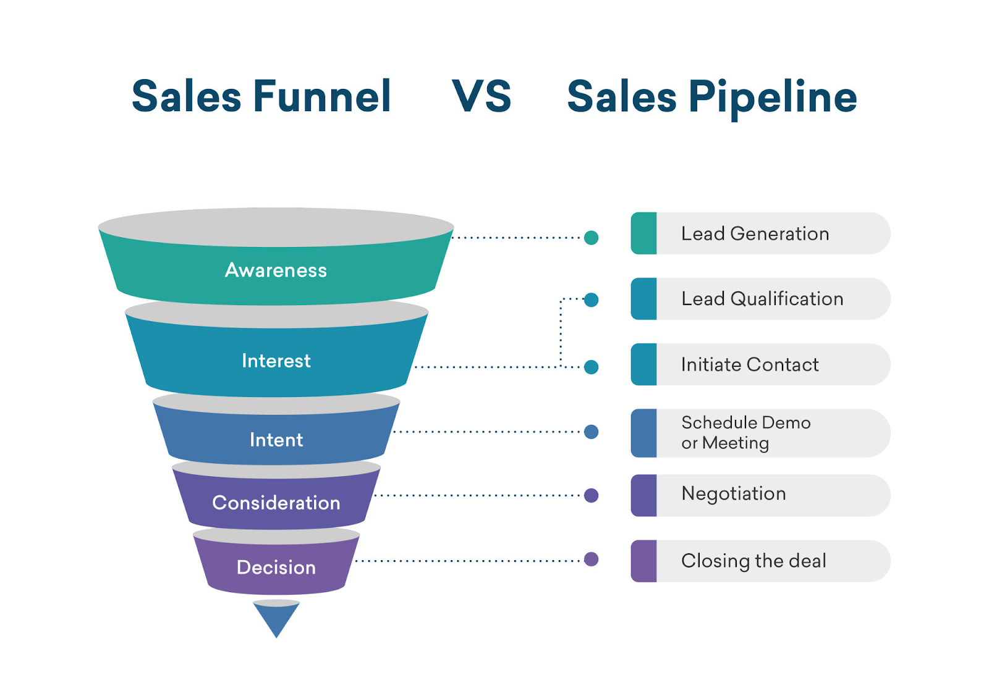

**Awareness for sales funnel:**

* The first of the sales funnel stages is called the “awareness” level, because it's where people first become aware of your product or service. They may hear about you from your advertising, social media, even word of mouth.
* Awareness is the uppermost stage of the marketing funnel. Potential customers are drawn into this stage through marketing campaigns and consumer research and discovery.
* This updated sales funnel includes five stages: Awareness: making buyers aware of your product as a solution to a specific pain point or problem. Consideration: buyers are considering your solution instead of competitors' solutions. Conversion: customer makes a final purchase decision.
* When someone becomes aware of your brand and turns into a potential customer. Interest: When a potential customer becomes interested in your brand's offerings. Desire: When a potential customer's interest becomes a desire for your brand's offerings.
* the primary goals of marketing at the top of the funnel are awareness and lead generation.

**Interest for sales funnel:**

* Funnels are usually made of stainless steel, aluminium, glass, or plastic. The material used in its construction should be sturdy enough to withstand the weight of the substance being transferred, and it should not react with the substance.
* A sales funnel helps you understand what potential customers are thinking and doing at each stage of the purchasing journey. These insights allow you to invest in the right marketing activities and channels, create the most relevant messaging during each stage and turn more prospects into paying customers.
* Good sales funnels must have a customer-first approach. The best place to start when creating or optimizing your funnel is researching your prospects' recurring problems, questions, behaviors, and decision-making processes. Make sure you take the time to understand your audience or audiences
* Action. The most important stage of the funnel — whether the prospect makes a purchase or not. If they don't buy from you now, that doesn't mean the deal is lost forever. You can create nurture campaigns to make sure you stay on top of their mind for any future needs.
* Marketing funnels are a useful tool to help you visualize the path customers take from first finding out about your brand to converting. Understanding them provides valuable insight into why some customers convert — and some don't. Understanding how — and when — consumers interact with your brand is crucial.
* The marketing funnel is based on the Awareness-Interest-Desire-Action (AIDA) model, first developed in 1898 by E. St. Elmo Lewis, an advertising advocate.
* If you aren't bringing in enough traffic, then your sales funnel has no chance to work. If you don't have enough visitors to your website or landing pages, then you won't have enough subscribers. If you don't have enough subscribers, then you won't have enough (or any) sales.

**INTENT:**

Intent. At the Intent stage, your prospect makes the transition to the lower funnel. They're now interested in buying your product, but haven't made the purchase just yet. They might indicate their interest by taking a survey, watching a product demo, or placing an item in their shopping cart.

**Four sales funnel stages**

* Step 1 — Define your audience's needs
* Step 2 — Create something valuable to offer
* Step 3 — Build a landing page
* Step 4 — Establish lead nurturing strategies

A sales funnel helps you understand what potential customers are thinking and doing at each stage of the purchasing journey. These insights allow you to invest in the right marketing activities and channels, create the most relevant messaging during each stage and turn more prospects into paying customers.

**The five stages of a sales funnel include:**

1. Awareness. A sales funnel starts when someone first becomes aware of your company, product or service
2. Interest. Once a person becomes aware of your brand, the next funnel stage is to develop their interest in your business and learn about your offers
3. Desire
4. Action
5. Loyalty

**Consideration:**

* At the consideration stage, consumers interested in your business and its offerings are considering whether or not to buy. Depending on your business, this could include guides, webinars, reviews, white papers, case studies, comparison charts, and much more.
* Representing the top of the funnel, this stage includes the most people. Consideration stage: The prospective buyer now wants to find and compare solutions to their problem, and they are looking for a solution that they can trust.
* What are consideration objectives? Consideration objectives sit in the middle of your marketing funnel. Campaigns like these are for people who know who you are and want to learn more. Their purpose is to motivate your audience to take a low level, easy action, like visiting your website or joining your email list.
* The consideration stage is essentially where your potential buyers consider your product or services as a possible option to solve the problem that you helped identify in the awareness stage.
* Once people have learned about your brand, they're likely to take an interest in it. At this point, you've hooked the fish, but you haven't yet reeled it in – which makes it one of the most important stages in the sales funnel.
* The consideration stage of the brand funnel measures how many people or the percentage of those who are aware of your brand, would actually consider making a purchase. Only brands that have a compelling offer which aligns with and can deliver on the goals of the target market will be considered.

Decision :

* .Third sales funnel stage. The customer is ready to buy and may consider several options before purchasing. They'll compare pricing, packages and other factors to find the best option. At this stage, you should make your best offer.
* Good sales funnels must have a customer-first approach. *The best* place *to* start when *creating or optimizing your funnel is* researching your prospects' recurring problems, questions, behaviors, and decision-making processes. Make sure you take the time to understand *your audience or audiences*

**sales funnel stages:**

* Stage 1: Awareness

The first of the sales funnel stages is called the “awareness” level, because it's where people first become aware of your product or service

* Stage 2: Interest
* Stage 3: Decision
* Stage 4: Action
* Build a landing page
* Offer something of value
* Start nurturing
* Upsell

**DAC_PHASE 3 Submission document**

# ****Data Preprocessing****

Data preprocessing can refer to manipulation or dropping of data before it is used in order to ensure or enhance performance, and is an important step in the data mining process. The phrase "garbage in, garbage *out" is particularly applicable to data mining and machine learning*

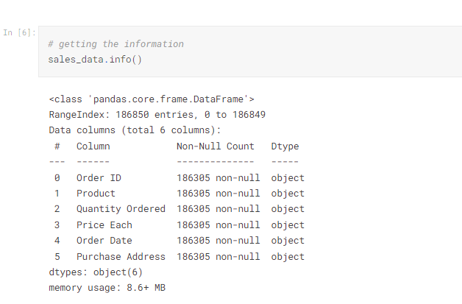

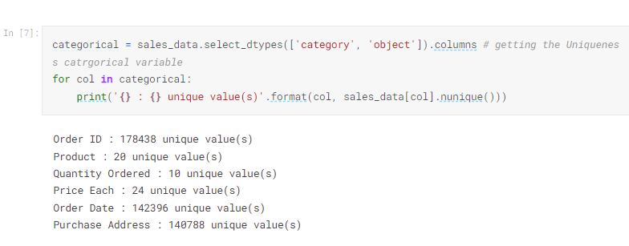

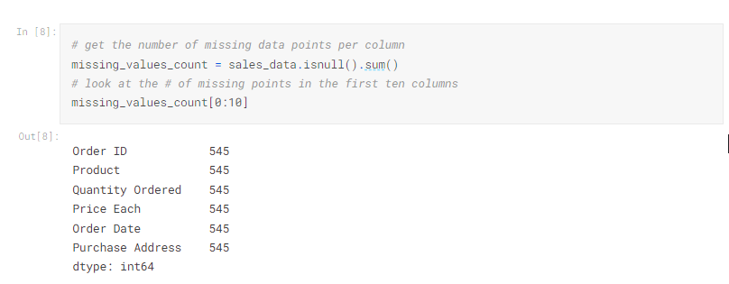

It might be helpful to see what percentage of the values in our dataset were missing to give us a better sense of the scale of this problem:

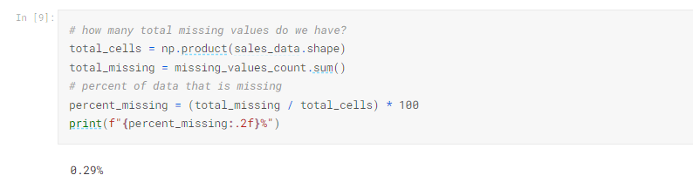

**Data Analysis**

Data Analysis is the process of systematically applying statistical and/or logical techniques to describe and illustrate, condense and recap, and evaluate data. Indeed, researchers generally analyze for patterns in observations through the entire data collection phase (Savenye, Robinson, 20042004). analyze and investigate data sets and summarize their main characteristics, often employing data visualization methods.

Or, the easier, you can say in Data Analysis we (Data Scientist or Data Analyst) what ever you want to call that, in this section, we're looking for the correlation and also the relationships between every data (features and labels) or the variables using and applying the statistical and visualization methods for looking some patterns.

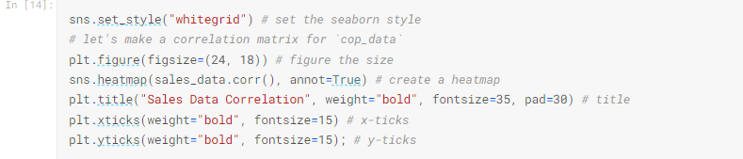

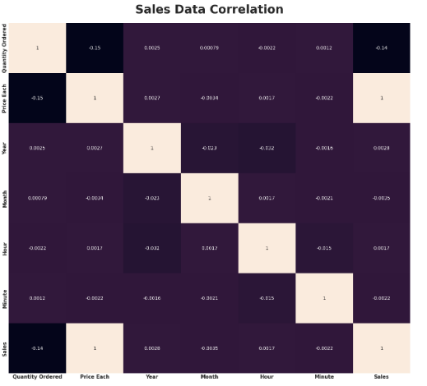

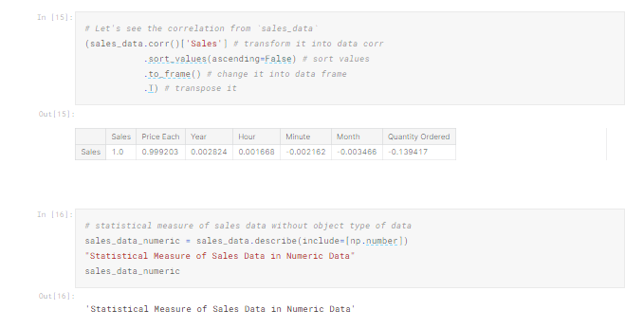

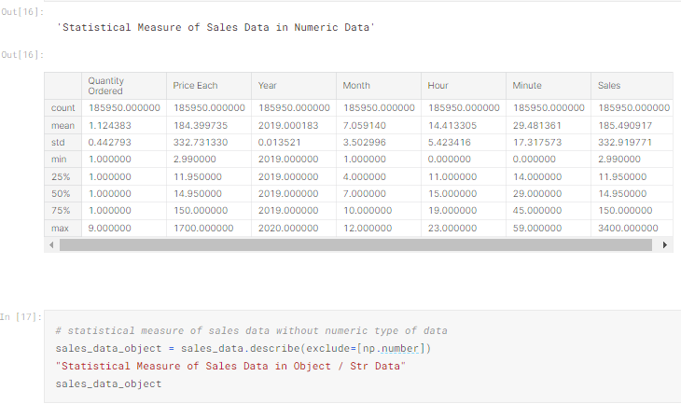

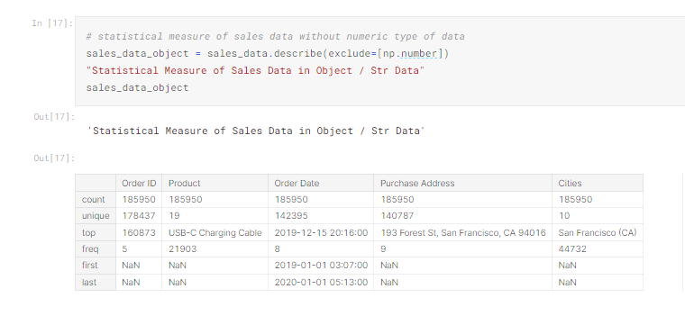

## **Quantity Ordered**

Find the proportion that lies in between two standard deviation (σ�) from mean (μ�), and let's try to interprete that. and In the Quantity Ordered Data, the μ=1.12�=1.12 and the σ=0.44�=0.44, then without further ado let's calculate it.

#### **Calculation:**

* 1.12−2(0.44)=0.21.12−2(0.44)=0.2
* 1.12+2(0.44)=21.12+2(0.44)=2

#### Interpretation:

At least 75%75% of the Sales Data Quantity Ordered population in the USA has a Quantity Ordered range from 0−20−2 item/product.

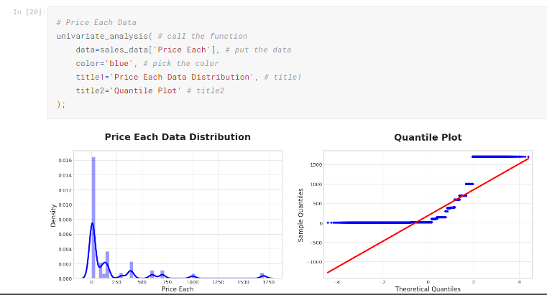

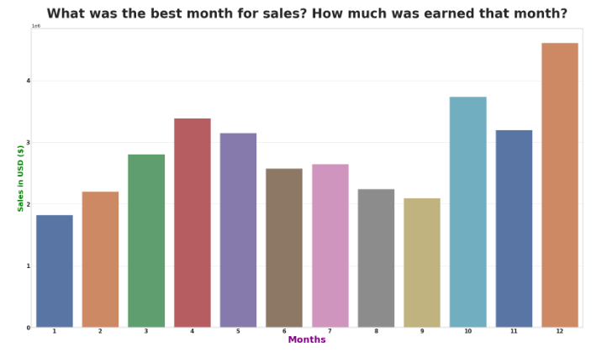

### Answer:

The best month to sell is shown in the visualization above is December which has a record number of sales reaching $4,613,443$4,613,443, sales,This may be because in December there is Christmas, where many people buy groceries to make cakes or toys as gifts for loved ones.

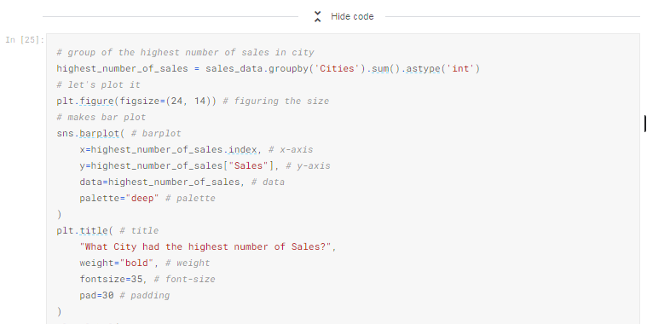

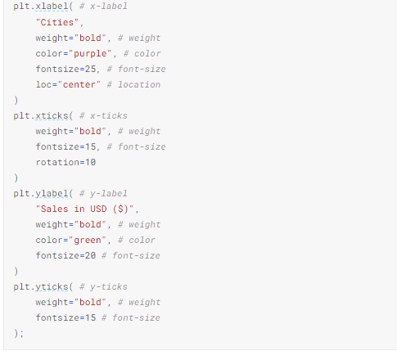

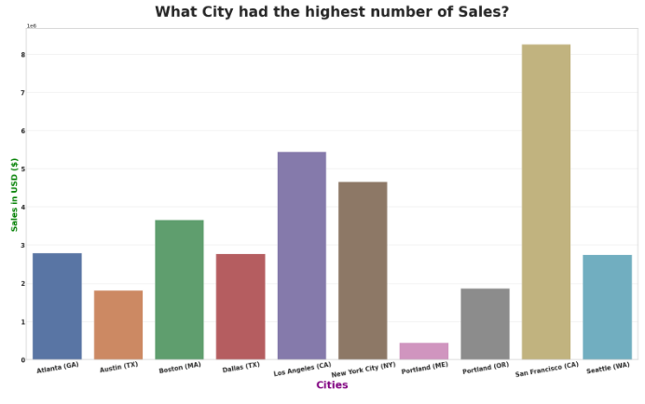

### Answer:

The city that has the most sales data in the above visualization is San Francisco, with total sales reaching $8,262,203$8,262,203

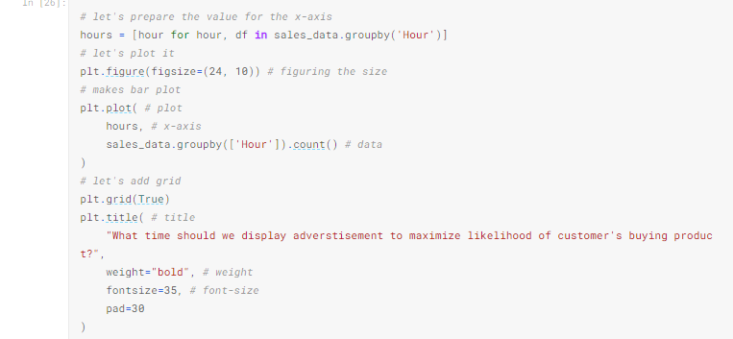

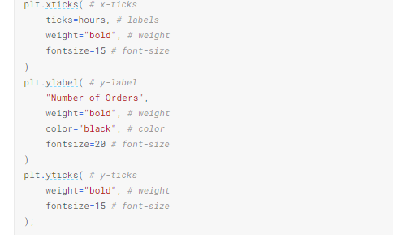

**DAC_PHASE 4 Submission Document Part 2**

**Data Collection:**

Gather relevant sales data, which may include transaction records, customer information, product details, and market trends.

**Data Preprocessing:**

Clean the data by handling missing values, outliers, and duplicates. This is also the stage where you perform feature engineering to create new features that might be useful for analysis.

**Exploratory Data Analysis (EDA):**

Visualize and explore the data to gain insights into sales trends, patterns, and relationships. This step can involve generating charts, histograms, and summary statistics.

**Feature Engineering:**

Create new features or transform existing ones to improve the model's performance. This can involve techniques like one-hot encoding, scaling, and creating interaction terms.

**Model Selection:**

Choose the appropriate machine learning or statistical model for sales prediction. Common models include linear regression, decision trees, random forests, or more advanced models like neural networks.

**Model Training:**

Train the selected model on your dataset using techniques such as cross-validation to ensure it generalizes well to new data.

**Model Evaluation:**

Assess the model's performance using relevant evaluation metrics like Mean Absolute Error (MAE), Mean Squared Error (MSE), or Root Mean Squared Error (RMSE). You might also use techniques like k-fold cross-validation for a more robust assessment.

**Hyperparameter Tuning:**

Optimize the model's hyperparameters to improve its predictive accuracy. This may involve grid search or random search.

**Model Deployment:**

If the model meets the desired performance criteria, deploy it to make predictions on new sales data. This could be integrated into a business intelligence tool, a web application, or another suitable platform.

**Monitoring and Maintenance:**

Continuously monitor the model's performance in a production environment and update it as needed.

**Reporting and Visualization:**

Create reports and visualizations to communicate the results and insights from the analysis to stakeholders. Tools like Tableau or Power BI can be helpful for this purpose.

Each of these steps is essential in conducting a thorough sales analysis that can lead to better decision-making and improved business outcomes.

**Discretization**

Discretization involves taking a set of data values and grouping sets of them together logically into bins (or buckets). Binning can apply to numerical values as well as to categorical data values. This could help prevent data from overfitting but comes at the cost of loss of granularity of data. The grouping of data can be done as follows:

### **Categorical Encoding**

Categorical encoding is the technique used to encode categorical features into numerical values, which are usually simpler for an algorithm to understand. One hot encoding(OHE)  is a popularly used technique of categorical encoding. Here, categorical values are converted into simple numerical 1’s and 0’s without losing information. As with other techniques, OHE has disadvantages and must be used sparingly. It could dramatically increase the number of features and result in highly correlated features.

### **Feature Splitting**

Splitting features into parts can sometimes improve the value of the features toward the target to be learned. For instance, in this case, Date better contributes to the target function than Date and Time.

### **Handling Outliers**

Outliers are unusually high or low values in the dataset, which are unlikely to occur in normal scenarios. Since these outliers could adversely affect your prediction, they must be handled appropriately. The various methods of handling outliers include:

* Removal: The records containing outliers are removed from the distribution. However, the presence of outliers over multiple variables could result in losing out on a large portion of the datasheet with this method.
* Replacing values: The outliers could alternatively bed treated as missing values and replaced by using appropriate imputation.
* Capping: Capping the maximum and minimum values and replacing them with an arbitrary value or a value from a variable distribution.

### **Scaling**

Feature scaling is done owing to the sensitivity of some[machine learning algorithms](https://www.projectpro.io/article/7-types-of-classification-algorithms-in-machine-learning/435) to the scale of the input values. This technique of feature scaling is sometimes referred to as feature normalization. The commonly used scaling processes include:

* **Min-Max Scaling-** This process involves rescaling all values in a feature from 0 to 1. In other words, the minimum value in the original range will take 0, the maximum value will take 1, and the rest of the values between the two extremes will be appropriately scaled.
* **Standardization/Variance Scaling-** All the data points are subtracted by their mean, and the result is divided by the distribution's variance to arrive at a distribution with a 0 mean and variance of 1.

**CONCLUSION:**

Concluding a product sales analysis involves summarizing the key findings and insights from the analysis. Here's a general framework for concluding a product sales analysis:

1. Key Findings: Start by highlighting the most important findings from your analysis. This should include data-driven insights about product performance, trends, and patterns.
2. Sales Performance: Provide an overview of how each product or product category has performed in terms of sales. This can include metrics such as revenue, units sold, and profitability.
3. Seasonal Trends: Discuss any seasonal trends or variations in sales. Identify the months or periods when sales are typically higher or lower and explain the reasons for these trends.
4. Market Trends: Analyze broader market trends that may have influenced product sales. Factors such as changes in consumer behavior, economic conditions, and industry trends can impact sales.
5. Customer Segmentation: If relevant, discuss how different customer segments (e.g., demographics, geography, or psychographics) have influenced product sales. Understanding your customer base can be crucial for tailoring marketing and sales strategies.
6. Competitor Analysis: Assess the competitive landscape and how it has impacted product sales. This might include a comparison of your product's performance with similar products from competitors.
7. Recommendations: Based on the analysis, provide recommendations for improving or sustaining product sales. These recommendations could cover areas such as pricing strategies, marketing campaigns, product improvements, or distribution channels.